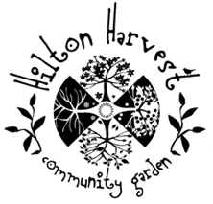
HILTON HARVEST COMMUNITY GARDEN
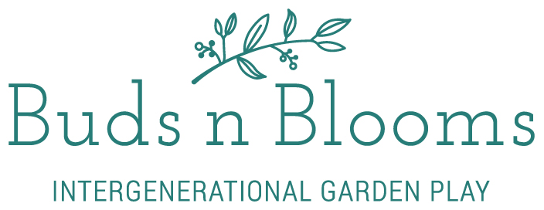

Buds n Blooms Intergenerational Nature Play Group provide a community led, highly enriched, sensory and outdoor learning and play environment for all ages. This is a space to connect with nature and community alike, and to enjoy and be inspired by nature.

Our weekly program aims to ensure that children and seniors have an opportunity to connect and engage with the environment in a garden based setting, led by our highly skilled gardening and environmental teaching facilitators.

Some of the activities participants may enjoy at Buds n Blooms include: planting and tending to our edible garden, nature art, feeding chickens and collecting their eggs, making food from harvested produce, playing and building in our nature/wild play space, and much more.

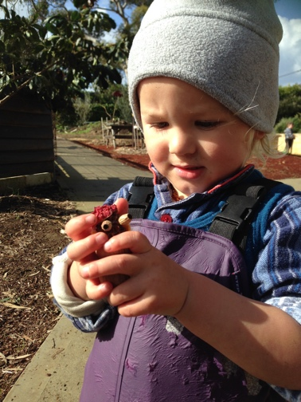
Intergenerational Gardening Group Benefits
- Getting outside into nature and the garden
- Engaging in intergenerational interactions
- Engaging all senses
- A nurturing and supportive environment
- Making connections within the community
- Learning about our environment and where food comes from
- Learning about healthy eating
- Developing a sense of place and connection to the land

What happens at Buds n Blooms?
You will be welcomed when you arrive at Buds n Blooms by the Facilitator and/or assistant facilitator.
We begin the official session with a special welcome around the circle; as well a brief overview of what wonderful workshop and activities you and your child/children/elder will be experiencing over the morning.
Regardless of what workshop is planned, we will spend time in the garden, and encourage you to pick from the Buds n Blooms garden bed. We will have a harvest basket which you can take from at the end of each session, this produce will be picked fresh from the garden throughout the session. We will feed the chickens and collect the eggs before morning tea, and make a ‘garden tea’ with herbs from the garden for all to enjoy.
Attendees have the option of joining in on the group activities, watering the BnB garden, planting seeds, or simply embracing in some wild play in the garden. Parents/Carers are encouraged to follow their child's/elder’s lead.
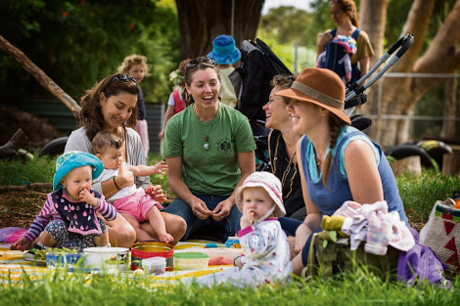
At Buds n Blooms, we will learn about the environment, the garden and its creatures in a very
natural way through flexible sessions. Our planned activities will be adjusted according
to the weather.
At morning tea time, everyone is encouraged to bring something to share. We will enjoy seasonal garden produce while listening to a story or song. Playgroup will then end with a closing circle/song of farewell till next time.

General Safety
We’ve conducted a “Venue Benefit Risk Assessment” identifying potential safety hazards and
risks, and ask all participants to familiarise yourself with this document prior to attendance.
Our Buds n Blooms Facilitator will discuss any important safety concerns and information with you at the beginning of each session.
Please remember, is your responsibility at all times to ensure that you are close to your child/elder,
and able to intervene when needed.
Some plants at Hilton Harvest are not edible. It’s best not to pick or eat any plants, unless invited to by a knowledgeable Garden Volunteer, or the BnB Facilitator.
Hilton Harvest has Public Liability Insurance.
What is the role of the Buds n Blooms Facilitator?
Our Buds n Blooms Facilitator is present to support and guide, offering ideas for gardening and nature play and art activities for your child/elder to enjoy. Parents/Carers are still responsible for their child/elder at all times, and it is your responsibility to decide what type of activities you feel comfortable with your child/elder partaking in.
Our Playgroup Leader holds a current First Aid Certificate & Working with Children Check.

What should we bring to Buds n Blooms?
Sessions will run outdoors in all weather. Buds n Blooms will have access to the Hilton Harvest tearoom and some stormy weather events may see the session relocated to the neighbouring pcyc facility.
We suggest bringing change of clothes, gumboots, wet weather gear such as waterproof
pants and raincoats in all seasons. Ensure to bring hats, sunscreen & insect repellent. There
is access to water onsite. We ask you to bring some morning tea for yourselves or to share at morning tea time. And we often make something from the garden to all to enjoy. Tea and coffee is available free of charge.
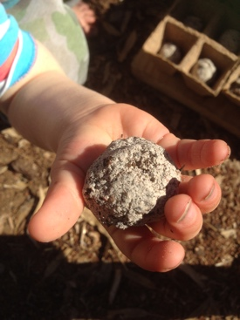
What age group is Buds n Blooms suitable for?
All ages from 0-100
Our activities and workshops are structured and directed towards ages 0-7, but remain age inclusive for all to participate in and enjoy.

Where is Buds n Blooms located?
Buds n Blooms is located at Hilton Harvest Community Garden, Rennie Crescent South, Hilton.
To read more about Hilton Harvest and what we’re all about and how to get involved, visit the website at http://hiltonharvest.weebly.com/

How do I sign up/enrol?
Buds n Blooms has an open doors policy, so bookings are not essential.
We require you to sign up, which can be done here ——-> https://goo.gl/forms/4fvztXSr2Bk8vYhq2
Or when you attend your first session.
Once you have completed your online enrolment, you will receive a confirmation email with further details about the seasonal program.
For any other enquiries please email budsnbloomshhcg@gmail.com
Venue Benefit Risk Assessment
Activity Buds n Blooms | Location 21 Rennie Crescent South HILTON
Types of activity Gardening, digging, feeding chickens, collecting eggs, picking fruit/vegetables/herbs, walking, running, exploring, building, walking barefoot, making and playing with mud, playing in the dirt, playing with sticks, painting with mud, water play, loose parts play, exploration of environs, wild play, playing in garden cubby, nature crafts and other self-directed nature-based activities.
Benefits of these activities
Activity | Developmental Benefit
Gardening | Exploring how things grow; where food comes from; the elements; the composition of soil; engaging all senses
Playing imaginative games using the resources  nature provides | Open ended learning allows children to explore at their own pace and with their own challenges
Observing changes in nature | Making observations, predicting patterns and  outcomes
Counting found objects, categorising found  objects, finding patterns in nature | Exploring mathematical concepts, visual  discrimination
Arranging items to make an installation | Using natural materials creatively; creating with an emphasis on the “journey of doing” rather than the outcome
Life Drawing | Creative; observation of flora, fauna and natural surroundings
Walking on logs and rocks, nature play, wild play | Gross motor co-ordination; body awareness in  space and movement; understanding risk and  considering actions
Play involving effects of water on our  environment e.g. puddles, mud play | Awareness of effects of weather on environment; science: changes; properties of mud, soil

Hazard Identification & Assessment
Potential  Hazard | Precautions / Control Measures | Who / When | Risk Assessment  (matrix) after  precautions
Sticks/leaves/dirt  and ground cover | Inform children/carers of the hazard to  allow self-evaluation  Remove where appropriate | Facilitator, children  and carers / ongoing | Moderate
Weather  elements | Sun – keep hydrated, wear sunscreen  and protective clothing, seek shelter  Rain – wear appropriate clothing, seek  shelter if the rain is too strong  Extreme cold – wear appropriate  clothing. Weather is unlikely to be so  cold that it would prevent Buds n Blooms from continuing | Facilitator and carers /  ongoing | Low
Insects and  arachnids | Direct children and their carers to keep  an eye out for insects and spiders. If  discovered, wildlife can be observed,  and understood. Children will be  informed that they should refrain from  touching spiders or insects that they  find, unless they are considered to be safe | Facilitator, children  and carers / ongoing | Low
Falling tree  branches | Facilitator will survey the area before  each session and assess whether there is an immediate risk of falling tree branches. The Hilton Harvest Committee will be informed if there is any suspicion of risk | Facilitator, children  and carers / ongoing | Moderate
Child wandering  off in the garden and adjoining School/ Bush areas | Whilst there is plenty of clear space in  our Hilton Harvest area, we are part of a  larger green space and there is a lot of  space to wander off. Carers will be advised to keep their own children within their sight (and vice versa). Facilitator will provide an extra pair of eyes when possible | Facilitator, children  and carers / ongoing | Low
Bushfire | Facilitator will check the current  warnings when required | DFES, Facilitator &  carers / Bushfire  season | Low
Cars driving into  the carpark | This is possible during arrival and departure from Buds n Blooms, please supervise children at all times | Facilitator, children  and carers / ongoing | Low
Road within 20m nearby | Inform carers that there is a road at the periphery of the area we are exploring | Facilitator, children  and carers / ongoing | Low
Snakes | Inform children and carers that snakes  live in this environment  ● Keep in close contact with children at  all times  ● Direct children and carers not to  approach a snake. “Stand still, remain  calm and wait until the snake moves out  of the way” | Facilitator, children  and carers / ongoing | Moderate
January 2019 (to be reviewed and updated January 2020)

Buds n Blooms Form 2020
Online version -----> https://goo.gl/forms/4fvztXSr2Bk8vYhq2

SECTION 1 - Your Details *
First Name ______________________________ Surname ______________________________
Email Address _________________________________________________________________
Phone No (mob) ________________________________________
Address (Suburb) ________________________________________
Age group (please circle)
18-24 25-35 35-50 50-75 75+
Emergency Contact – Name _____________________________________________
Phone No (mob) ____________________________________________

OPTIONAL Second Parent/Carer Details
Please fill out for the parent/carer who will attend playgroup, and who wishes to be the contact person for the Playgroup.
Should this role be shared a second parent/carer may be added.

Name _______________________________ Surname ______________________________
Email Address __________________________________________________________________
Phone No (mob) ________________________________________

Are there other attendees in your care? * (please circle)
YES (continue onto section 2) NO (go to section 3)

SECTION 2 – Other Attendees Details
Name __________________________________________________
Date of Birth _____ /_____ /_____
2nd Attendees Name __________________________________________________
Date of Birth _____ /_____ /_____
3rd Attendees Name __________________________________________________
Date of Birth _____ /_____ /_____
4th Attendees Name __________________________________________________
Date of Birth _____ /_____ /_____

SECTION 3 – Important information and Consent
Things we may need to be aware of
Do you have any cultural or family needs t one respected whilst attending the Buds n Blooms sessions?______________________________________________________________________________________________________
Are there any allergies, medical or special needs our Buds n Blooms facilitators need to be aware of?
Please include any dietary restrictions.
______________________________________________________________________________________________________
Venue Benefit Risk Assessment – January 2019 document read and understood (please circle) *
YES NO

Media Consent
Buds n Blooms may take pictures of activities being undertaken by the playgroup for use in media related publications.
Do you consent to yourself and others in your care being included in photographs and film? * (Please circle)
YES NO Maybe (speak to BnB facilitator)

2019 Preferred Sign Up & Payment Option (circle your preferred option)
- Buds n Blooms Membership ($125 for annual family admission)
- 10 session card ($60 per family)
- Casual attendance ($8 per session)

Signed: ____________________________________ Date of enrolment: ____/____ 2019

Structure of Buds n Blooms
Arrival and greeting (9.30am)
Welcome circle and introduction to activities (9.40am)
Commence workshop/ garden activities (9.45am)
Feed chicken and collect eggs (10.20am)
Morning tea time (10.30am)
Commence pack away/ Farewell families (11.15am)
* times are indicative only

Buds n Blooms Fees 2020
(Anyone attending must fill out the Sign Up Form)
Full Year Buds n Blooms Membership (40 sessions)
$125 for family (up to three children)
$110 for individual/single parent
$250 for group/school (4+ adults/children)

10 session card (valid for 6 months)
$60 per family

Casual attendance
$8 per child/elder

Attendance fees are payable in CASH on the day of attendance, or by prior direct debit to:
HILTON HARVEST COMMUNITY GARDEN INC
BSB: 633 000
ACC: 136962198
(Tag with ‘BnB’ and your family name)

